CHORD DRILL 2, ditambah chord Fm dan Em

### Intro
```
C G Am F
```

### Verse
```
C G Am F
C G F C
C G Am F
C G F C
```

### Reff
```
C G Am F
C G F C
Am Em F Dm
Fm C G F
```

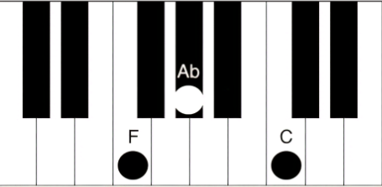
### Verse
```
C G Am F
C G F C
C G Am F
C G F C
```

### Interlude
```
C G Am F
```

### Reff
```
C G Am F
C G F C
Am Em F Dm
Fm C G F
```

### Outro
```
C G Am F
C G F C



